Need to be done on the below accounts.

363108362589 (atos-aws-p11-ra01-np)NonProd

975226774250 (atos-aws-p11-ra02-np)Sandbox

**Step1**: Login to the AWS account search for EC2.

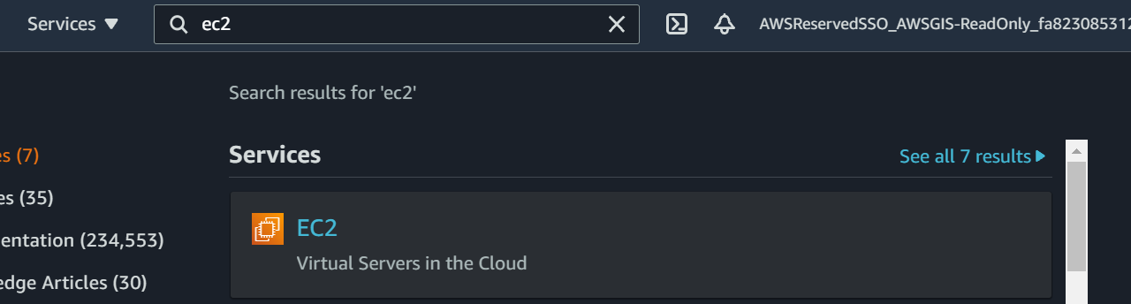

Step2: Under EC2 check for Snapshot.

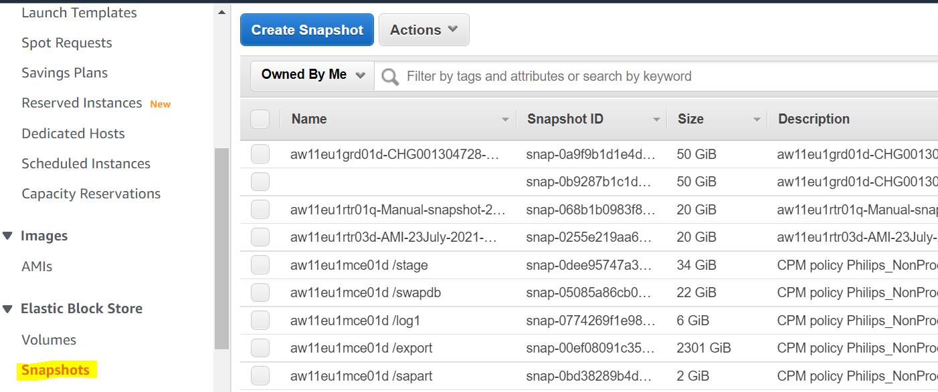

Step 3: In Filter search for Started

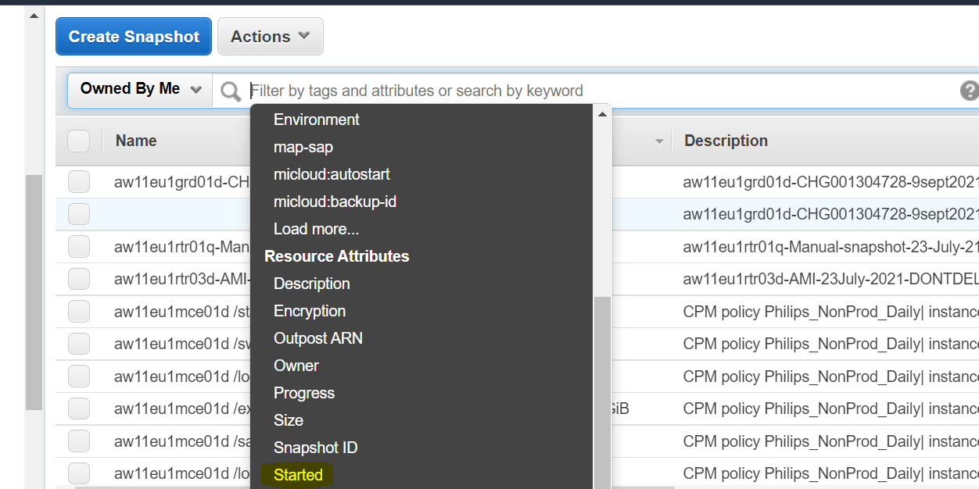

Step 4 Select for before this date.

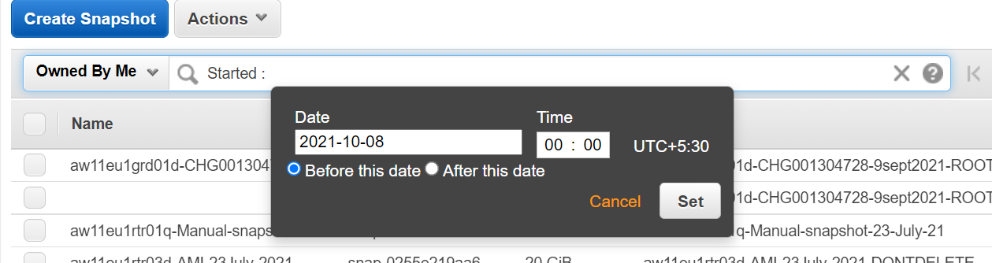

Step 5: Select 7 days before from the present date.

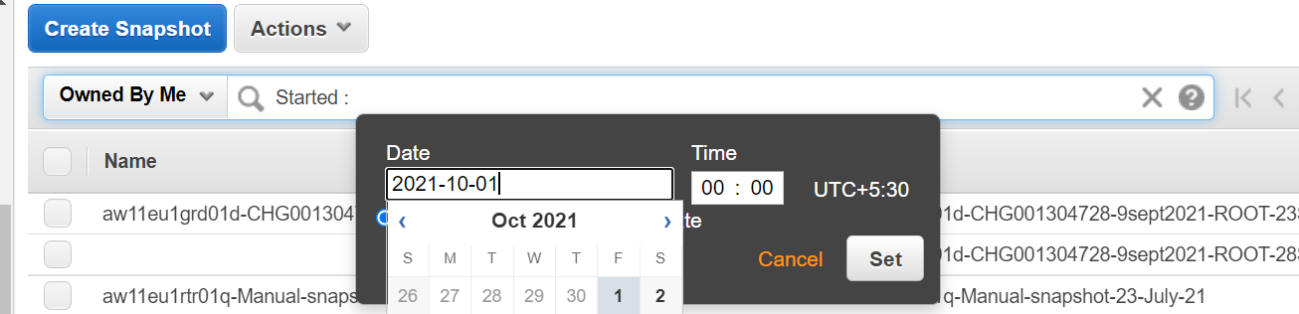

Step6: Set and see for the result, if there is any snapshot older than 7 days from present date. Kindly investigate and take necessary steps with the help of the team.

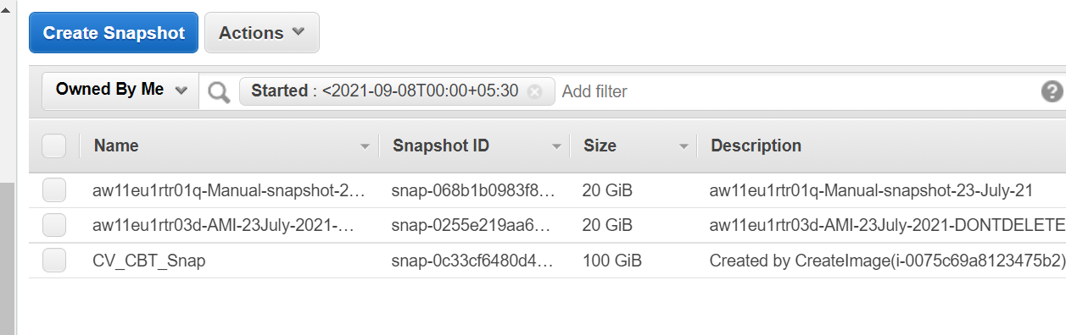

**PROD Snapshot:**

**Need to be done on all 3 accounts.**

155484157719 (atos-aws-p11-ra01-p)Production

904275948294 (atos-aws-p11-ra02-p)Core Services

835635460036 (atos-aws-p11-ba01-p)ICE DR

**Step1**: Login to the AWS account search for EC2.

**Step2**: Under EC2 check for Snapshot.

**Step 3**: In Filter search for Started.

Step 4 Select for before this date.

**Step 5:** Select 30 days before from the present date.

**Step6**: Set and see for the result, If there is any snapshot older than 30 days from present date. Kindly investigate and take necessary steps with the help of the team.

